HUrricane

**Vision**

# **Introduction**

This document outlines the vision for HU-FDS, a simplified food delivery system that provides fast, secure, and reliable food ordering for everyone. The goal is to seamlessly connect restaurants, customers, and couriers in the simplest way possible.

As demand for online food delivery grows, a more efficient and reliable system becomes essential. HU-FDS aims to offer a quicker and more user-friendly alternative to existing food delivery applications. This vision document is intended for stakeholders, couriers, developers, and restaurants. It is a foundation for the system’s development, ensuring alignment with user needs and market demand. [1]

# **Positioning**

## **Problem Statement**

| The problem of | Increasing demand for online food delivery |
| --- | --- |
| affects | The restaurants, customers, couriers, website admins, and developers who develop the system |
| the impact of which is | People need better, easy-to-use websites and applications to order food securely, simply, and fast. |
| a successful solution would be | A dynamic and user-friendly website that provides an efficient and seamless service for customers, restaurants, and couriers at the same time.[[1]](https://docs.google.com/document/d/10g1Z37OOxIkbMbmpT-YYXJR42HwVNiOH/edit?pli=1#bookmark=id.lfs9bg1njp20) |

## **Product Position Statement**

| For | the people who have internet access and the ability to place an order, the restaurant owners, and the couriers.[[1]](https://docs.google.com/document/d/10g1Z37OOxIkbMbmpT-YYXJR42HwVNiOH/edit?pli=1#bookmark=id.lfs9bg1njp20) |
| --- | --- |
| Who | wants to order food online, wants to grow their businesses, and wants to work with restaurants. |
| PentaCode | is an online food order platform. |
| That | ensures a simple ordering process with a well-designed interface and fast, solution-oriented customer service. |
| Unlike | YemekSepeti, Getir Yemek, Migros Yemek |
| Our product | Our product offers a platform that allows customers to order food, enables restaurants to manage orders, and helps couriers handle deliveries efficiently, all powered by AI technologies and equipped with the best tools.[[1]](https://docs.google.com/document/d/10g1Z37OOxIkbMbmpT-YYXJR42HwVNiOH/edit?pli=1#bookmark=id.lfs9bg1njp20) |

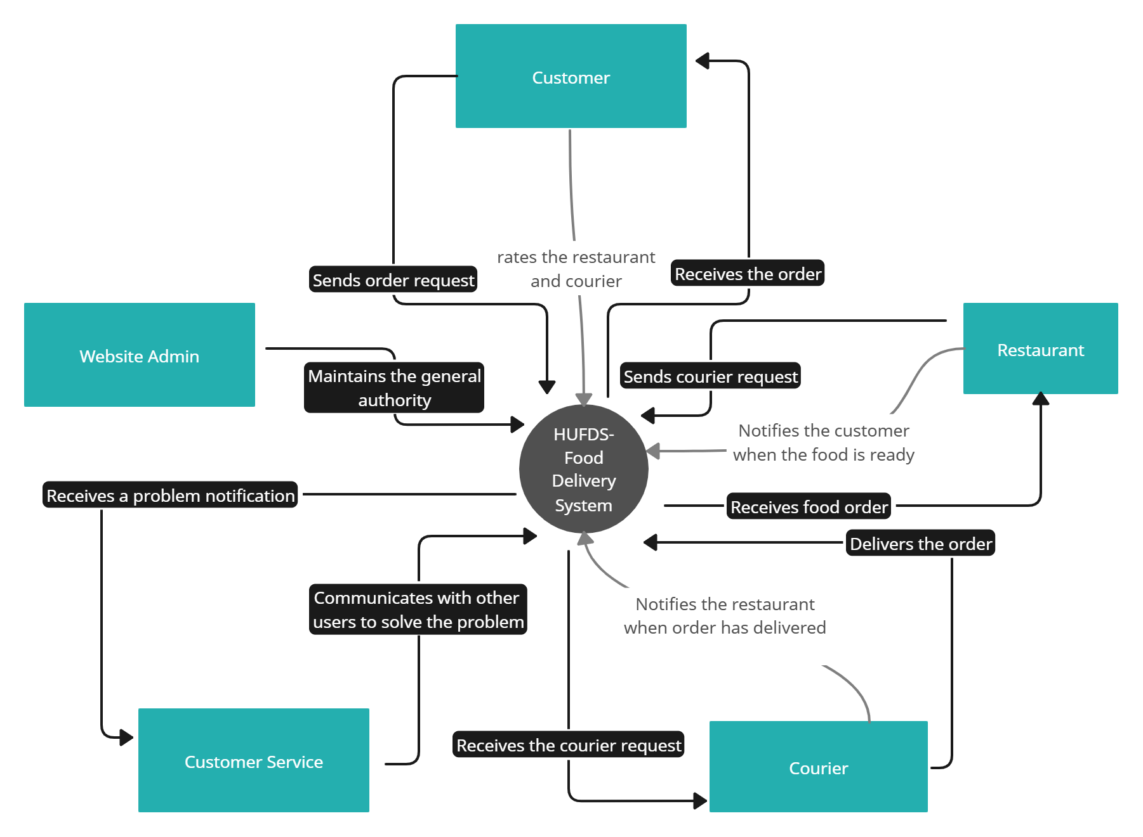

# **Stakeholder Descriptions**

## **Stakeholder Summary**

| **Name** | **Description** | **Responsibilities** |
| --- | --- | --- |
| Users | the restaurant owners,  the couriers,  the website admins of PentaCode | maintain the restaurant menu, state, contact etc.  ensure a delivery service for the contracted restaurants.  maintain the stability and security of the website. |
| Developers | developer team, which is going to develop PentaCode | will create server-side functionalities such as database integration, API endpoints etc. As well as client-side functionalities like a graphical user interface and interactive layouts for easier use. |
| Investors & Business Partners | the people who invested in this website | approves funding and financial support for future updates |
| Product Owner & Business Analyst | the person/team that defines the product and gathers the business requirements | state features and functionalities based on customer needs |
| Support & Customer Service Team | the customer support team to solve conflicts and problems with users | maintain user satisfaction in case a problem occurs |
| Customer | the people who are going to use the app for food orders, | use the website to order food online,  browse the restaurants and their menus. |

## **User Environment**[2]

At least four people complete each task. The customer places the order, and the restaurant manager accepts it. The manager notifies the kitchen to prepare the food and calls the courier for delivery. However, the number of people working in the kitchen may vary.

Customer gives the order: The restaurant starts to process the order in and finishes it in 5–20 minutes. Then, the order is assigned to a courier, who delivers it in 10–30 minutes. However, time intervals may vary based on real-life conditions. Therefore, the courier may be delayed due to rain, issues in the kitchen may extend preparation time, or a connection problem may cause the order to fail to reach the restaurant's system.

At checkout, the customer will be charged a delivery fee to be given to the courier. Also, there will be a network between couriers and restaurants to make easier the courier assignment process. System stores customer’s payment information securely.

Customers rely on devices that have internet connections from varied locations; restaurants work in fixed, equipment-dependent kitchens. Couriers navigate outdoor routes amid weather and traffic so, they expected to use the mobile version of the system. The system will run on modern web technologies and be accessible via browsers on both desktop and mobile devices. In the future, mobile applications will be developed that integrate with the application's database. Also, the system should be quite responsive since the target devices change between phones, tablets, and computers.

Additionally, support for a chatbot will be implemented through integration with an LLM API. Since couriers may not deliver the order on time, especially during peak hours, the project will have a solution as "ChatBot" working with LLM, to please the customer.

The system will support multiple languages, including both Turkish and English, for both the graphical user interface (GUI) and the chatbot. The payment gateway and navigation system may be implemented as well.

# **Product Overview**

## **Needs and Features****[**2**]**

| **Need** | **Priority** | **Features** | **Planned Release** |
| --- | --- | --- | --- |
| Customer Dashboard | High | The general capability to view restaurant options, browse menus, customize orders, and add items to a cart. | Version 1.1 |
| Restaurant Dashboard | High | Order management, price management, food management, customer management, contact management, etc. | Version 1.0 |
| Courier Dashboard | High | Courier dashboard features include contact information, delivery time information, order status tracking, etc. | Version 1.0 |
| Admin Dashboard | High | Includes the authority to ban restaurants and couriers that act against the website's policies. Also have general authority about orders, restaurants, couriers, customers, etc. | Version 1.2 |
| Support Chat | Medium | It will consist of both AI and real support chats, as well as a ticket and phone system for more detailed support. | Version 1.3 |

# **Other Product Requirements**

| **Hardware Requirements** | **Priority** | **Planned Release** |
| --- | --- | --- |
| Hosting | High | Version 1.4 |
| Mobil Support | Low | Version 1.5 |
| Web-based Platform | High | Version 1.0 |

# 

| **Performance Requirements** | **Priority** | **Planned Release** |
| --- | --- | --- |
| Load Time | High | Version 1.1 |
| User Interaction Response Time | High | Version 1.1 |
| Concurrency | Medium | Version 1.4 |
| Scalability | Medium | Version 1.0 |

# 

| **Environmental Requirements** | **Priority** | **Planned Release** |
| --- | --- | --- |
| Network Connection | High | Version 1.0 |
| Modern Web Browser with HTML and JavaScript | High | Version 1.0 |

# 

| **Quality Ranges** | **Target** |
| --- | --- |
| Performance | System should handle multiple requests smoothly, actions should feel instant. |
| Robustness | System should handle unexpected inputs, situations. |
| Fault Tolerance | Back-ups should be taken periodically in case of a system crash, also the system must recover with minimal loss. |
| Usability | Easy and intuitive GUI for better user experience. |
| Scalability | Scalability: As more users or data come in, the system should be able to keep up without slowing down or crashing. |

# 

# 6. Traceability Table

| Work/Team member | Salih Eren Yüzbaşıoğlu | Yusuf Küçüköner | Şükriye Öztürk | Bedirhan Gençaslan | Mustafa Furkan Ateş |
| --- | --- | --- | --- | --- | --- |
| Project Vision 1-2 | 3h | 1h | 3h | 1h | 0h |
| Project Vision 3-7 | 1h | 3h | 2h | 2h | 4h |
| total effort | 4h | 4h | 5h | 3h | 4h |

# 7. Prompts

**Conversation link:** [**https://chatgpt.com/share/67cf3316-f228-800f-897f-46cb33330606**](https://chatgpt.com/share/67cf3316-f228-800f-897f-46cb33330606)**Conversation link:** [**https://chatgpt.com/share/67cee49a-07dc-8000-822e-0f1b38921c53**](https://chatgpt.com/share/67cee49a-07dc-8000-822e-0f1b38921c53) **gpt.txt**